 **GREENWOOD COLLEGE**

YEAR 12 Applications 2016/17

Chapter 1, Test 1 Section 1

**Time: 30 Minutes No calculators allowed No notes**

NAME:__________________________________ **Marks:____ /30**

**1. [8 marks: 2, 2, 2, 2]**

Mrs Mazzart teaches Music and Mathematics. She wishes to investigate the claim that mathematical competence and music competence are related. Together with some of her students, they design a statistical investigation to study this claim.

a) State a possible response and explanatory variable for the investigation.

b) Describe the data that need to be collected and how the data is to be collected.

c) Describe how you would display and analyse the data.

d) Describe how you would interpret the data you analysed.

**2. [2 marks]**

The linear relationship between two variables, x and y, is described as negative. The least squares regression line has equation y=*a*+*b*x.

Determine with reasons which of the following statement(s) must be true.

a) Both *a* and *b* must be positive

b) Both *a* and *b* must be negative

c) *a* must be positive

d) *a* must be negative

e) *b* must be negative

3. [6 marks: 1, 1, 2, 2]

The worldwide consumption of coal (in billion tonnes of oil equivalent, BTOE) is shown in the graph below from 1965 until 2010. A billion is one thousand million.



(a) Use the graph to estimate the worldwide consumption of coal in 2005 in

billion tonnes of oil equivalent.

(b) Add a trend line to the scatterplot.

(c) Estimate the worldwide consumption of coal in

(i) 1960.

(ii) 2030.

(d) Which estimate in (c) is more reliable? Explain your reasoning.

**4) [8 marks]**

Determine the explanatory variable and response variable for each of the following:

a) Arm length and height.

Explanatory variable:__________________

Response variable:___________________

b) Weekly pay and the number of hours worked

Explanatory variable:__________________

Response variable:___________________

c) Number of skiers and amount of snow

Explanatory variable:__________________

Response variable:___________________

d) Consumption of coffee and heart rate

Explanatory variable:__________________

Response variable:___________________

**5) [6 marks]**

State each of the following variables as:

Numerical and discrete or continuous

Categorical and nominal or ordinal

i) Number of supporters at a cricket match

ii) Body temperature

iii) Star movie rating

 **GREENWOOD COLLEGE**

YEAR 12 Applications 2016/17

Chapter 1, Test 1 Section 2

**Time: 30 Minutes calculators allowed one page of notes**

NAME:__________________________________ **Marks:____ /32**

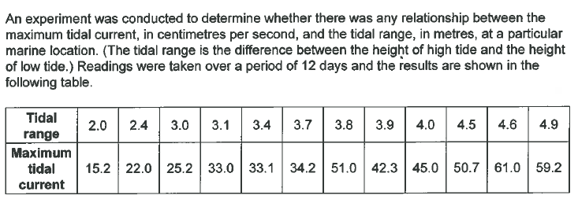**1. [9 marks: 1, 2, 2, 2, 2]**

1. State the explanatory variable.
2. 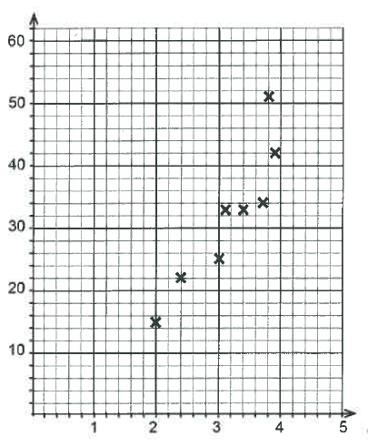Complete the scatterplot below by plotting the last four data points and labelling the horizontal axis and the vertical axis clearly.

c) Calculate the correlation coefficient for the data, and comment briefly on your answer with reference to the appearance of the scatterplot in part (b).

1. i) Determine the equation for the least-squares line that models these data. State the slope and vertical-intercept correct to one decimal place.

ii) Draw this line on the scatterplot in part (b) by showing two calculated points on the graph.

**2. [8 marks: 2, 2, 4]**

The accompanying diagram shows the different makes of cars parked at three different suburban shopping centres on a school-day morning. The shopping centres A, B and C are located respectively at high, middle and low income suburbs.

|  |  |  |  |
| --- | --- | --- | --- |
|  | **A** | **B** | **C** |
| **Australia** | 70 | 60 | 40 |
| **German** | 150 | 80 | 20 |
| **Korean** | 40 | 130 | 120 |
| **Japanese** | 90 | 140 | 110 |
| **Others** | 60 | 70 | 50 |

a) Complete the table below showing the row percentages.

|  |  |  |  |
| --- | --- | --- | --- |
|  | **A** | **B** | **C** |
| **Australia** | 41 | 35 | 24 |
| **German** |  |  |  |
| **Korean** | 14 | 45 | 41 |
| **Japanese** | 26 | 41 |  |
| **Others** | 33 | 39 | 28 |

b) Complete the table below showing the column percentages.

|  |  |  |  |
| --- | --- | --- | --- |
|  | **A** | **B** | **C** |
| **Australia** | 17 | 13 | 12 |
| **German** |  | 17 | 6 |
| **Korean** |  | 27 |  |
| **Japanese** | 22 | 29 |  |
| **Others** | 15 | 15 | 15 |

c) Determine with reasons if there is a relationship between the make of cars parked and the level of income of the suburb. Clearly identify the response and explanatory variables. State any assumptions you made.

**3. [15 marks: 2, 3, 1, 1, 2, 3, 1, 2]**

The following table displays the Number Employed (thousands) and the corresponding Annual Turnover (in $million) for several types of industry.

|  |  |  |
| --- | --- | --- |
| **Type of Industry** | **Number Employed(‘000),N** | **Annual Turnover $m, A** |
| Food, beverages | 160 | 43000 |
| Textiles | 75 | 10000 |
| Wood and paper | 60 | 11000 |
| Printing | 90 | 14000 |
| Energy Products | 90 | 30000 |
| Non-metal mineral products | 40 | 9000 |
| Metal products | 150 | 37000 |
| Machinery | 200 | 40000 |

a) Draw a scatter-graph for this data.

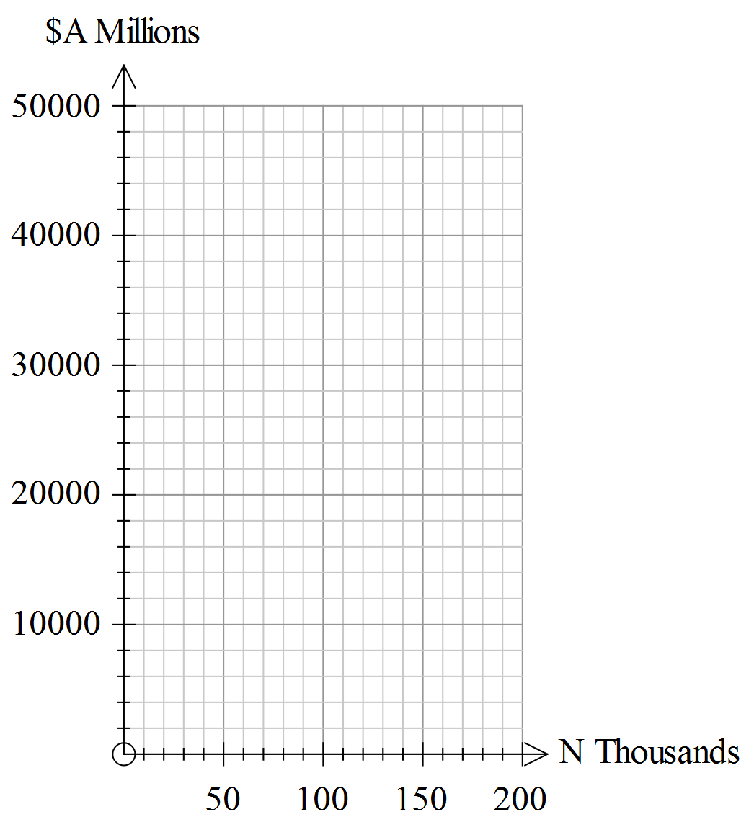

b) Calculate the coefficient of linear correlation and comment on the nature of the relationship between **N** and **A.**

c) Find the gradient of the least squares regression line of **A** and **N**

d) Find the vertical intercept of the least squares regression line of **A** and **N**

e) Determine the increase in turnover for every 10 000 increase in the number employed.

f) Use the least squares regression line to predict the annual turnover for a business that employs 5 000 people.

Comment on the reliability of your prediction.

g) An American reporter converts the turnover to US$ using the conversion AUD$1=US$0.70. Calculate the correlation coefficient between the Number employed and the Annual Turnover in US$.

h) Comment on the statement made by a politician that increasing the number of people employed will create a higher annual turnover.